You can have an organic, reduced sugar, dairy free Easter which tastes delicious – Author Miriam
McGuirk shows us how…

Author Miriam McGuirk’s strict nutritional diet has helped her to live well with M.E and Fibromyalgia for the past 19 years. Her diet cut’s out most refined sugars and yet Miriam still finds a way to enjoy chocolate at Easter with her ‘Easter Chocolate Bake’ – now you can try it too!

Having diet restrictions and intolerances means Miriam has to be vigilant with her food and finds a natural, clean diet has helped improve her health. Miriam only eats natural, in season, healthy foods, simply prepared. This leads Miriam to an organic, balanced diet packed full of protein, fresh vegetables (lots of green foods), salads and fruit twinned with natural supplements.

Miriam is not a chef, but her lifestyle decrees the need for creating and adapting her own menus. For many years Miriam worked in the hospitality industry opening up new restaurants, designing the food and wine menus and sourcing suppliers and using this experience, has created her own nutritional recipes that are inspiring and individual.

When in the UK, Miriam creates a much coveted chocolate and almond Easter cake to be shared with friends and family and uses only organic ingredients.

Miriam’s Easter Chocolate Bake Recipe:
-150g organic almonds (blanched, skinned
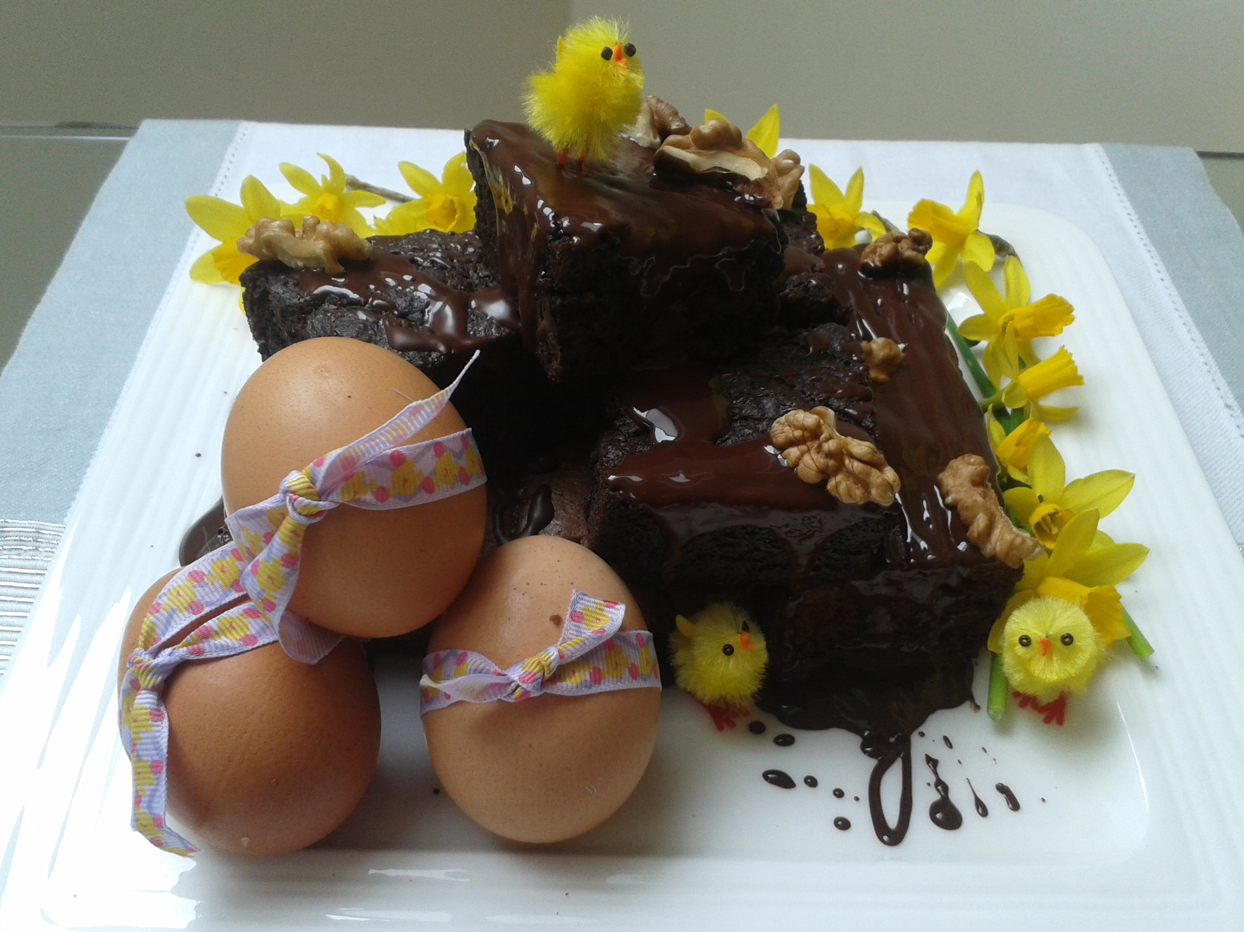
and roughly ground),
-150g goat’s butter,
-100g organic dark brown sugar,
-3 organic eggs,
-1tsp (flat) baking powder,
-75g of chopped walnuts or hazelnuts
(depending what is in season),
-125g of organic 70%+ dark chocolate,
- 1 tsp of honey (optional),
- 75g of soya or spelt flour (or a mix of both),

Method:
-Line and grease an 8” square tin (this is best for creating bakes that you can cut into flat squares)
- Set the oven to 170degrees (fan oven)
- Melt the butter and 100g of the chocolate in a bain-marie then leave to cool to room temperature.
- In a mixer blend the eggs and sugar together until thick and creamy and then slowly add the dry ingredients and honey (if required).
- With the mix well combined turn the mixer onto its lowest speed and slowly add in the melted chocolate and butter from the bain-marie. Ensure the melted chocolate and butter has cooled – the last thing you want to do is curdle the eggs!
- Pour the cake mixture into the cake tin.
- Smash the remaining 25g of chocolate into chunks and scatter on top of the cake mix, pushing them into the mixture. When baked these chocolate pieces will go all gooey and delicious!
- Bake in the oven on 170degrees for 30 minutes or until a skewer comes away from the centre of the bake clean.
- To dress the tray bake cut into squares like brownies and drizzle more dark chocolate over the top, dust with cocoa powder and walnuts – or simply devour as is!

Miriam said: “By supporting local farmers markets, organic or Fairtrade ingredients are easy to come by and this is a chocolate lover’s dream recipe – it’s simple, a healthier cake option and an ideal treat for an Easter celebration.”

“This is great for anyone with dairy intolerance, allergies or simply wanting a healthier Easter. Why miss out on all the chocolate fun? Try it as an Easter alternative!”

Miriam is the author of two books ‘Shattered Dreams & Scorpions at Midnight – A Pocketful of Inspiration’ £6.99 ‘Shattered Dreams & Scorpions at Midnight – a search for sanctuary’ £8.99. Both titles are published by mPowr Publishing.

You can follow Miriam via her Blogs and 'pics from the mountain' at www.miriammcguirk.com Facebook Pages - Miriam McGuirk and on Twitter @Miriam_McGuirk

